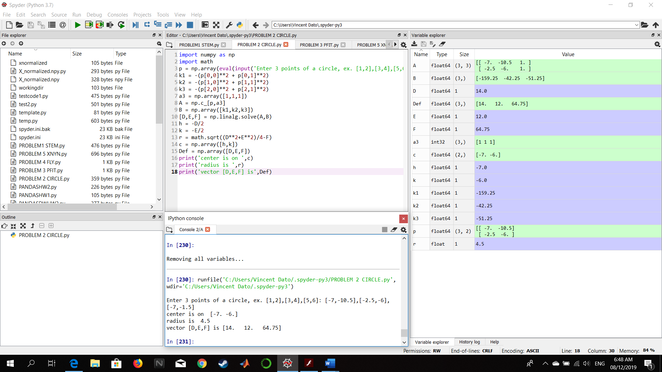PROBLEM 2 – PYTHON

Figure : Input values (-7,-10.5),(-2.5,-6),(-7,-1.5)

Figure : Screenshot of Code and Output



Figure : Output parameters: center as c, radius as r, vector [D,E,F] as Def